CDC - WORKSHEET

QUANTITATIVE APTITUDE AND LOGICAL REASONING

Questions:

  - Ram tells his son, “5 years ago, I was 5 times as old as you were then. Also 3 years from now, I shall be 3 times as old as you will be”. Find their present ages.
  - In a group of goats and peacocks, the number of legs is 14 more than twice the number of heads. The number of cows is:
  - A girl counted in the following way on the fingers of her left hand: She started by calling the thumb 1, the index finger 2, middle finger 3, ring finger 4, little finger 5 and then reversed direction calling the ring finger 6, middle finger 7 and so on. She counted upto 1994. She ended counting on which finger?
  - Directions: Study the following information carefully and answer the questions given below.
It has been given that-
A is + from point B states B is to the NORTH of A. A is = from point B states B is to the SOUTH of A. A is || from point B states A is to the East of B.
A is * from point B states A is to the WEST of B.
Now, S is =20 m from point P. Point Q is =15 m from point R. Point U is
+15 m from Point V. Point T is ||20 m from point V. Point U is ||16 m from point Q. Point R is ||30 m from point P.
Question: What is the shortest distance between point S and Q?
A 5 √ 37
B 7 √ 37
C 4 √ 65
D 2 √ 37
E None of these

  - Five friends Shakshi, Mithu, Mithuni, Deva and Jas are playing Hide and Seek and standing randomly. Mithu is to the northeast of Jas. Deva is 20 m to the east of Jas, who is 60 m to the west of Shakshi. Mithuni is to the northwest of Deva and in the line of Jas and Mithu. Deva is 40 m to the south of Mithu.

If Mithu is to look for Shakshi in the game, what distance she saves if she goes to Shakshi straight instead of first going to Deva and then reaching Shakshi?

A 42.47 m
B 56.60 m
C 27.34 m
D 23.44 m
E None of these

  - In a birthday party, every person shakes hand with every other person. If there was a total of 30 handshakes in the party, how many persons were present in the party?
  - Solve the Number puzzle

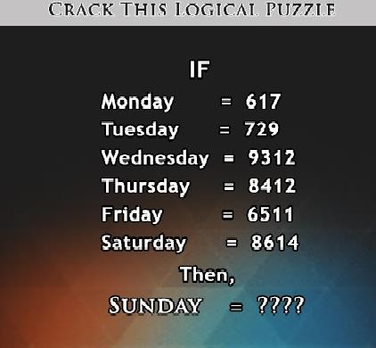
  - A is 12 years older to B and 9 years younger to C, while B and D are twins. How many years older is C to D?
  - The total number of digits used in numbering the pages of a book having 499 pages is.
  - Solve the Number puzzles
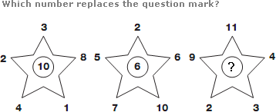

  - Find the odd one out N, L, J, H, G.

  - Find out the wrong term in the given series of numbers? 6, 15, 35, 77, 179, 221

  - The average temperature for Monday, Tuesday, Wednesday and Thursday was 48 degrees and for Tuesday, Wednesday, Thursday and Friday was 46 degrees. If the temperature on Monday was 42 degrees. Find the temperature on Friday?

  - Find out the wrong number in the series. 7, 8, 18, 57, 219, 1165, 6996.

  - Solve the Letter puzzle.

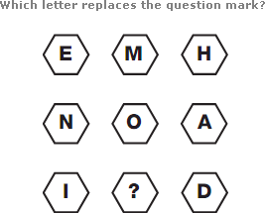

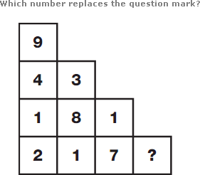
  - Solve the Number puzzle.

